June 2017 Year 2, Edition 6

Commandant’s corner

Marines and Associates,

Your detachment needs you! We live in a target rich environment for recruiting new members. Western North Carolina probably has more Marine veterans than anywhere else in NC except for the Jacksonville/Camp Lejeune area. We have to get out there and shake the bushes and recruit these Jar Heads! We also need Associate members! They can be from any branch of the military or civilians. If you know anybody that wants to be a part of a veterans organization focused on helping our veterans, tell them about your Marine Corps League.

Moving forward we have an exciting new networking tool about to come on line in WNC and it will be a HUGE tool in providing resource information to the veteran community. I will be going over that information at our next 2 meetings and the full roll out will happen on August 11th. We will be just one part of a larger networking system to make sure our veterans get all the help available to them.

One other item to be aware of; there is a little girl in Mission Hospital who was tragically hurt in a bicycle accident. Her parents are Marines and neither of them have substantial income. We will be donating to help this family with their medical expenses and there is a Go Fund Me account that has been established to provide a way for folks to donate independently. I will have all the information at the meeting. This has already gone out state wide to all the other detachments as well.

Semper Fidelis!
Commandant Ledford

NEXT MEETING: July 25, 2017

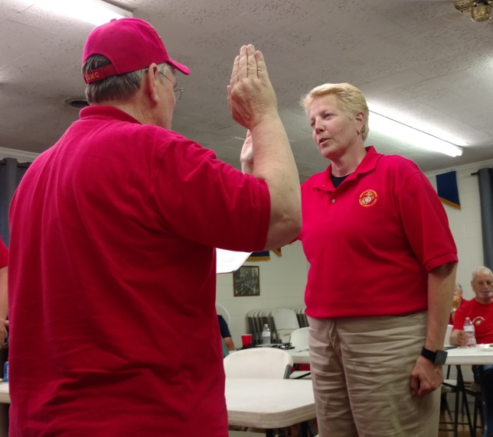Congratulations to our new Judge Advocate Cindy Douthit! Here she is being sworn in by DVC Larry Thornton at the May meeting.

Detachment 1417 Board:

Commandant: Ric Ledford

Sr Vice: Jeff Corpening

Jr Vice: Don Chatham

Judge Advocate: Cindy Douthit

Past Commandant: Larry Thornton

Chaplain: Gene Ray

Paymaster: Don Alexander

Sergeant-at-Arms: Bradley Parker

Adjutant/Newsletter/Webmaster Phaedra Laushance

Detachment Email:
mcl.asheville@gmail.com

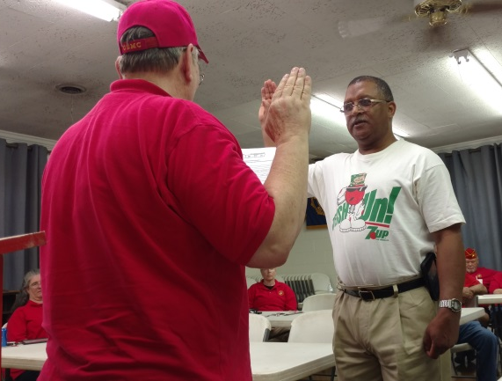
New member AJ Jefferson was sworn in at the May 2017 meeting by DVC Larry Thornton.

VA Shelves Plan to Cut Benefit for Elderly Disabled Veterans

The Department of Veterans Affairs on Wednesday June 14 shelved a proposal that would have cut the Individual Unemployability benefit for elderly and disabled veterans.
"To withdraw this benefit from people who rely on that money would be very difficult to do," VA Secretary Dr. David Shulkin said at a Senate Veterans Affairs Committee hearing.
Shulkin said that the proposal to cut IU came from an effort to make more efficient use of department funding, but it soon "became clear that this would be hurting some veterans, and I'm really concerned about that. I'm not going to pursue policies that hurt veterans."
The proposal to cut the benefit, which VA officials said averages about $1,600 a month, to about 330,000 veterans provoked furious opposition from those receiving it and from veterans service organizations.
The American Legion applauded "Secretary Shulkin's reversal on cutting funds" for the benefit.
"Since the president's FY-18 Department of Veterans Affairs budget request was submitted, we have been inundated with calls by veterans and family members who expressed alarm over the proposed cuts to their benefits and livelihoods," Legion National Commander Charles E. Schmidt said in a statement.
However, Carl Blake of the Paralyzed Veterans of America said he isn't sure that Shulkin has totally backed away from the IU cut proposal. He notes that the projected $3 billion in savings from the proposed IU cuts were slated to be used to expand the VA Choice program on private care.
"If we assume that's not going to happen," he said of the proposed IU cuts, "that's $3 billion that has to be addressed. So where do we go from here?"
John Rowan, national president of Vietnam Veterans of America, called on members of Congress and the VA to join in a public announcement that the IU cut proposal has been scrapped and will not be revived.
He said such a move is necessary to ease the concerns of elderly vets who fear they could lose their homes from the loss of income. "They've been climbing the walls," he said.
The veteran service organizations have been deluged with calls from IU recipients who urged them to fight the proposal.
Carlos Fuentes, legislative director of the 1.7 million-member Veterans of Foreign Wars, said VFW members had sent 40,000 letters of protest to members of Congress. He called the IU proposal an effort to "balance the budget on the backs of our nation's veterans."
Members of Congress were apparently feeling the pressure. Earlier this week, a House Appropriations subcommittee began considering language on the VA budget but left the IU cut proposal out of the markup.
On Monday, a letter from 57 members of Congress went to Shulkin urging him to kill the IU cut proposal, according to AMVETS.
In a statement, AMVETS said the letter showed the organization was making progress in its efforts to kill the IU cuts that "would leave hundreds of thousands of disabled senior citizen veterans destitute, desperate, and at increased risk of homelessness and suicide."
The proposal in President Donald Trump's $186.5 billion VA budget for fiscal 2018, an increase of six percent, would have changed eligibility rules for the IU program.
Under current rules, the IU program awards payouts at the 100 percent disabled rate to veterans who cannot find work due to service-connected injuries, even if their actual rating decision is less than that. The proposal would have cut off IU benefits once the veteran reached the eligibility age for Social Security.
In defending the proposed IU cuts last month to Congress, Shulkin said that the move was a "hard decision" but added, "I don't think we can continue to only expand services and not look at the ones we are delivering."
The plan to cut financial support for aging and disabled vets triggered a flurry of emails to Military.com suggesting that there could be a political backlash for Trump if the cuts went ahead.
"Make that guy in the White House keep his promise to all of us veterans, lest we all fall by the wayside and be left on the battlefield," said a former Army staff sergeant who served in Vietnam.
"Please don't do this to us," said a sailor who served on ships in the Tonkin Gulf in Vietnam. "My wife and I already live our later years in constant uncertainty. We thought our VA benefits were fairly safe."
"I have become aware that President Trump's VA budget sets to screw Vietnam veterans first in line by eliminating the unemployability benefit for those of us who actually served and sacrificed who have reached the age of Social Security benefits," said a former Navy lieutenant who flew the EP-3E version of the P-3 Orion surveillance aircraft in Vietnam.
"What can we do? Based on this, veterans would be in better shape if a Democrat had been elected," said another vet. "I voted for Trump because of promises of helping the veterans, not taking away. I surely hope I don't regret voting for him."

Annuitant Pay:

Defense Finance and Accounting Service
U.S. Military Annuitant Pay
8899 E 56th Street
Indianapolis IN 46249-1300

The old PO Boxes in London KY will remain open and all mail will be forwarded to the new address for one year. However, sending mail to the old address will add three to five days to the normal processing time.

The telephone and fax numbers are not changing.

Please copy and paste the following web address into your web browser for additional contact information:
https://www.dfas.mil/retiredmilitary.html

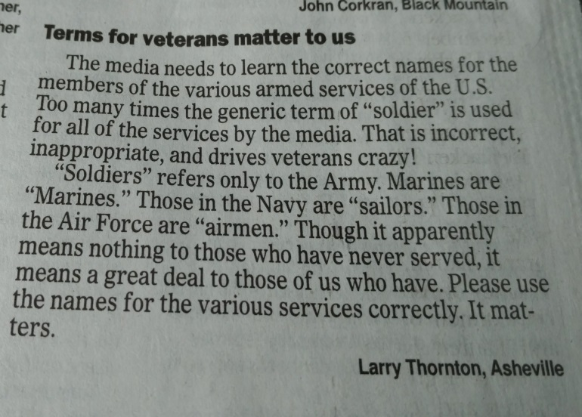

It has been requested that if you are part of the August Picnic committee that you stay for a quick meeting after the general meeting on Tuesday night. Thanks!

Remember…if you are doing ANY volunteering for veterans, please keep track of your hours and give them to Don Alexander at the meeting. They get turned in to the State for credit! Thanks!

Monthly Dinners:
(All dinners begin at 1800 (6pm) unless otherwise noted.

July 11th: Wild Wings Cafe, 65 Long Shoals Rd, Asheville
August 5th: Annual Picnic at the Fireman’s Camp, Clayton Rd, Arden
September 12th: Apollo Flame Bistro, 1025 Brevard Rd #1, Asheville
October 10th: Stone Ridge Tavern, 1003 Brevard Road, Asheville
November 10th: Marine Corps Ball
December 6th: O'Charley's—Detachment Christmas Party.

Do you know someone would enjoy being involved with the Detachment happenings? Are they a Marine or FMF Corpsman? If so, let Don Chatham know, and he will get some information sent! Or…direct them to our website! And don’t forget to grab some cards from Phil Swartz to hand out to potential members!

Our website address is:
www.ashevillemcl.org

Are you on Facebook? Join us on our Facebook page at https://www.facebook.com/marinecorpsleagueasheville/

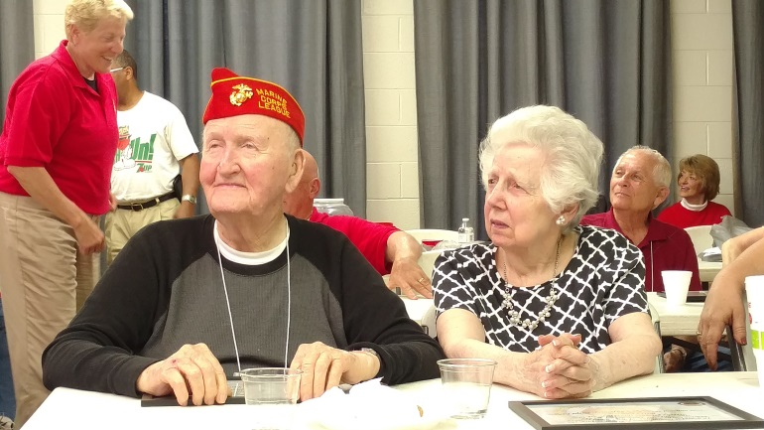
Bob and Betty Lawrence watch as many awards were given out at the May meeting.

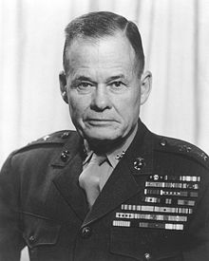
"Good night, Chesty, wherever you are!”

